 User Account Creation Script
There are two different ways you can use the script
- Log into a domain controller with your Admin account and run it on the DC
- Run it directly from your laptop under your Admin account credentials
The first method is easiest but the document shows how to do it from a laptop
- On the usercreateV2.exe hold the shift key and right click to do Run as different User
- Type in your Admin credentials
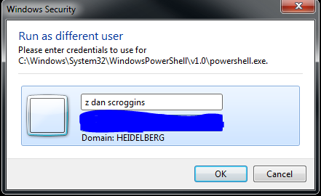
- Follow the prompts to enter in the user information
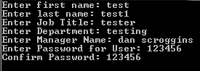
- Select the applicable company name (NOTE: This will set the users e-mail address in addition to Company name)
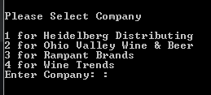

- Select the applicable office location (NOTE: This will set the office name,street address, city, state, and zip)
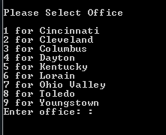
- Confirm if the listed information is correct
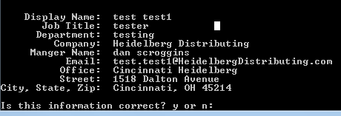
- If you hit no you be directed to the below screen to select what you want to correct
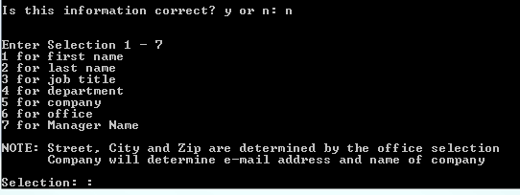

- If you hit yes the information is commited and the user will be created in the domain
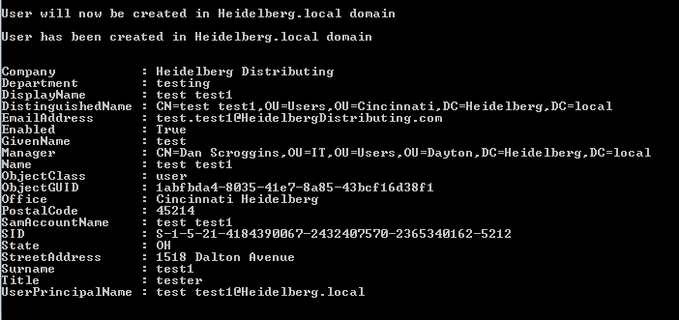

If you encounter any issues with the script please contact me
Name: Daniel Scroggins
Email: dan.scroggins@heidelbergdistributing.com
Spark: dscroggins
Cell: 937-824-0987

